**Password Protected PDF**

**Description**

A password-protected PDF is a type of PDF (Portable Document Format) file that has been encrypted with a password to restrict access to its contents. This security feature is commonly used to safeguard sensitive or confidential information within a document. When a PDF is password-protected, a user must enter the correct password to open and view the document.

**Typical Usage Scenario:**

Password-protected PDFs find application in various use cases where there is a need to secure sensitive information or control access to specific documents. Here are some common use cases for password-protected PDFs:

* Legal documents
* Employee Confidential information
* Protection of personal files
* Prevent Unauthorized edits and access.

**Prerequisites**

NA

**Features and Limitations**

Password-protecting a PDF document ensures that only individuals with the correct password can access its contents, maintaining the confidentiality of sensitive information.

Currently, it is only available for PDFs not any other type of document.

**Dependencies**

Requires Mendix 9.18.4 or above

**Installation**

1. Download Java action from marketplace.
2. Call the java action in microflow that you are using for generating PDF documents.
3. Pass 2 parameters in java action: Document and password

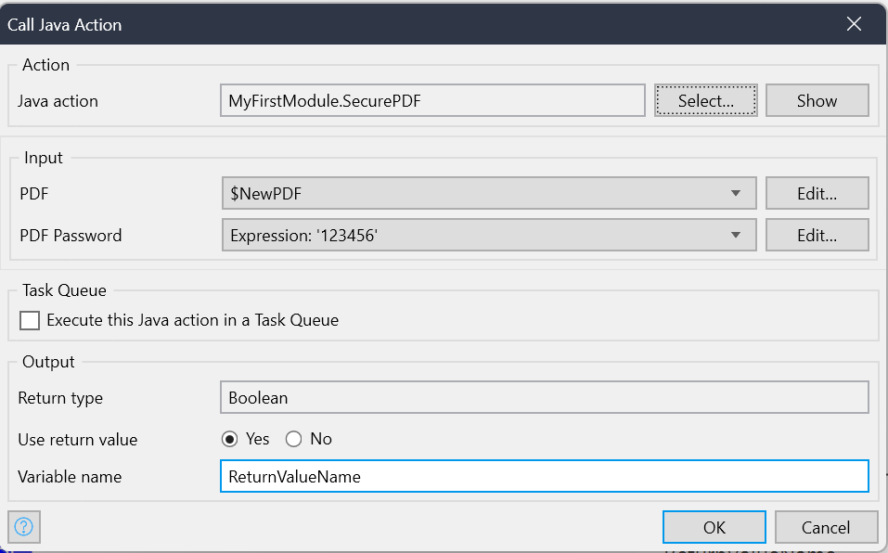

Java Action:

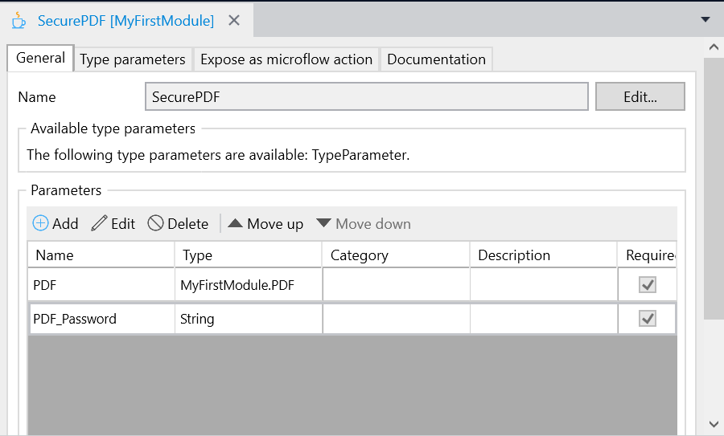

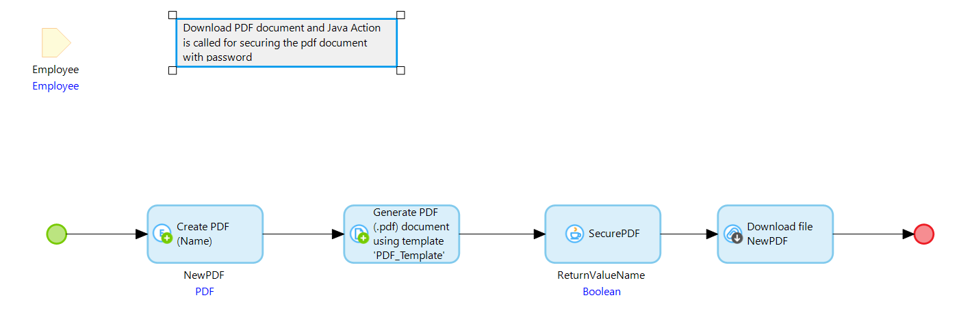

**Configuration: NA**

**Category: Module**

**Subcategory: All**

**Visibility: Public Marketplace**

**Studio Pro Version: 9.18.4**